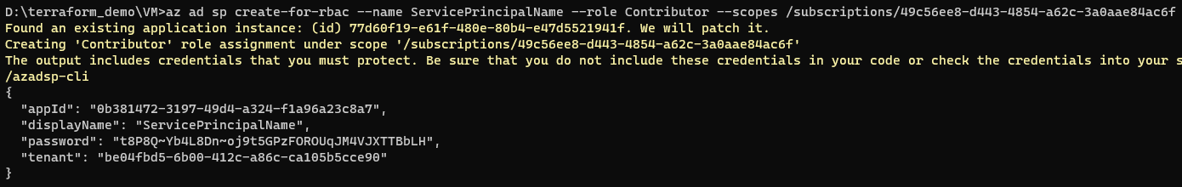

az ad sp create-for-rbac --name ServicePrincipalName --role Contributor --scopes /subscriptions/49c56ee8-d443-4854-a62c-3a0aae84ac6f

# az ad sp create-for-rbac --name ServicePrincipalName --role Contributor --scopes /subscriptions/49c56ee8-d443-4854-a62c-3a0aae84ac6f

# az account set --subscription 49c56ee8-d443-4854-a62c-3a0aae84ac6f